Game Design Document

Fill up the Following document

1. Write the title of your project.

Shooter Game.

1. What is the goal of the game?

Shoot the balloons that are randomly spawned using a arrow shooting gun.

1. Write a brief story of your game?

There are many game stalls in a fair and a kid named Ruhaan wanted to play the balloon

shooter game there. Let’s see how many balloons did he prick.

1. Which are the playing characters of this game?

* Playing characters are the ones which respond to the user based on the input from the user
* Cars, monkeys, dinos, wizards etc, are the playing characters in the game.

|  |  |  |
| --- | --- | --- |
| Number | Character Name | What can this character do? |
| 1 | Bow | It will shoot arrows and it will move up and down as the character moves. |
| 2 |  |  |
| 3 |  |  |
| 4 |  |  |
| 5 |  |  |
| 6 |  |  |
| 7 |  |  |
| 8 |  |  |

1. Which are the Non Playing Characters of this game?

* Non Playing characters are the ones which don't have an action or a behaviour when the user interacts with the game.
* Hurdles, stones, bananas, coins, etc are non playing characters in the game.

|  |  |  |
| --- | --- | --- |
| Number | Character Name | What can this character do? |
| 1 | Arrow | It will be shot by the bow. |
| 2 | Balloons | Non playing characters(NPCs). |
| 3 |  |  |
| 4 |  |  |
| 5 |  |  |
| 6 |  |  |
| 7 |  |  |
| 8 |  |  |

Draw your imagination of this game. What does this game look like?

* Draw the game either on your computer or on paper,
* Add images of scenes of the game to show each of the playing and non-playing characters at least once.

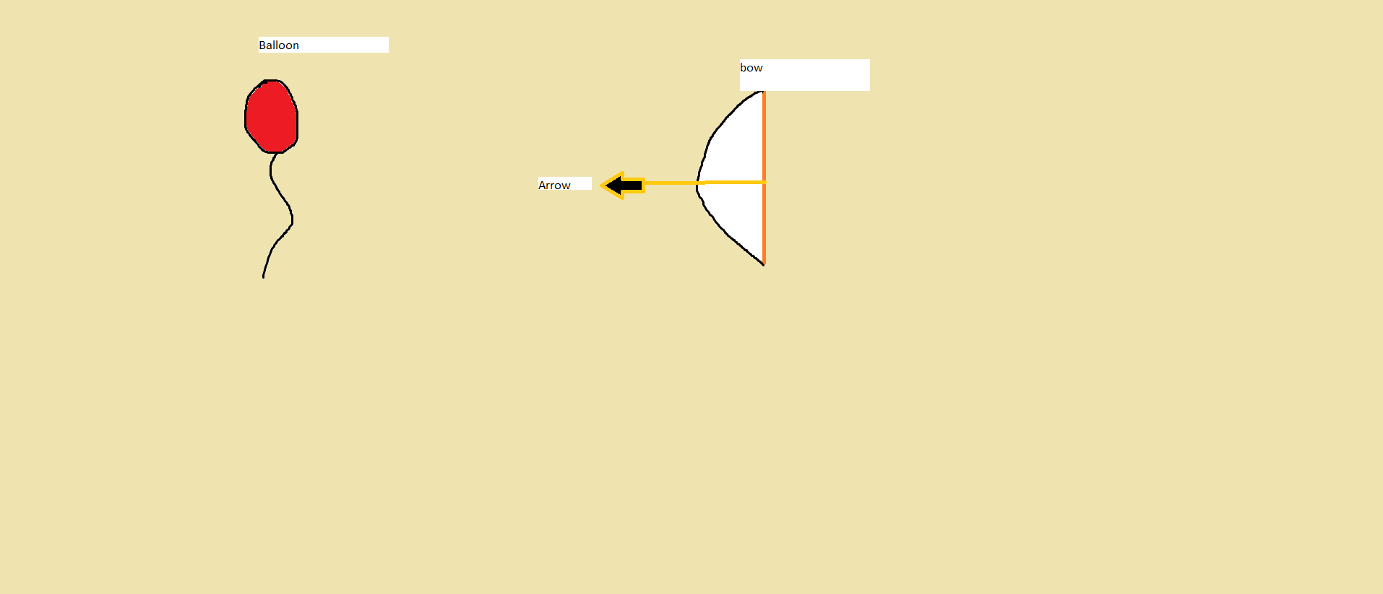

How do you plan to make your game engaging?

There will be a score that will be change with the time. In the beginning there will be 1 balloon coming at a time, but as the game advances, there will be more balloons spawned randomly faster.